St. Luke Catholic Church
7575 Holliday Drive E
Indianapolis, IN 46260

Parent Preparation Handbook

First Reconciliation and First Communion
2023-2024

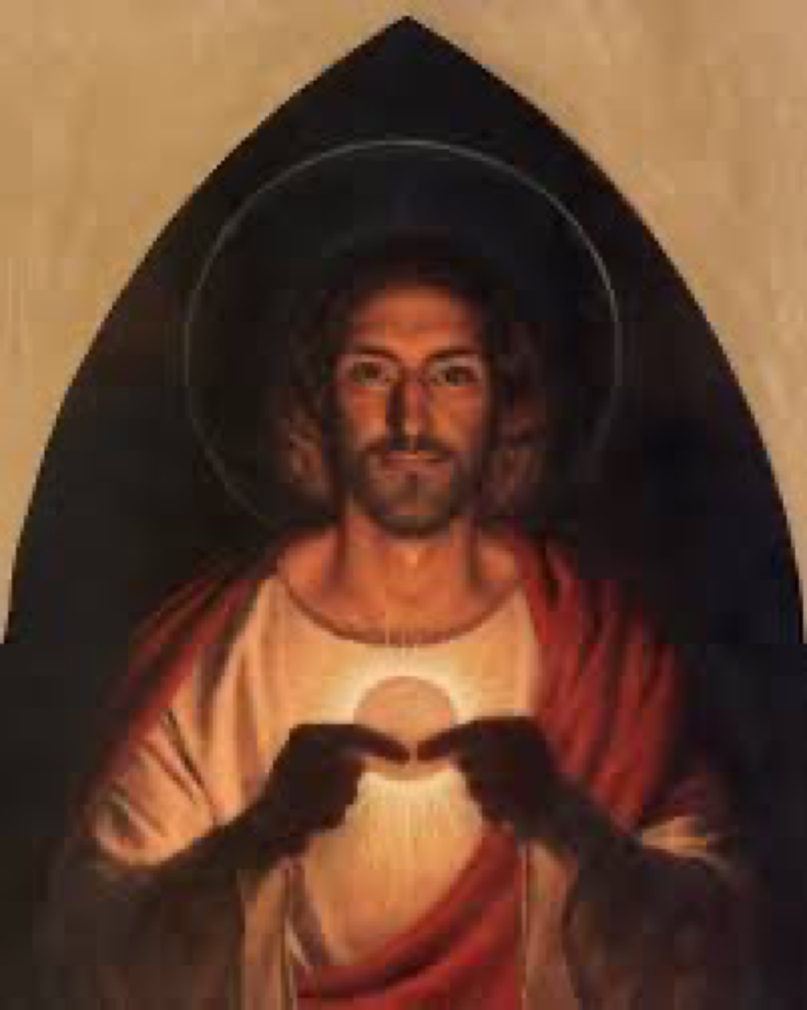

I am the bread of life; whoever comes to me will never hunger, and whoever believes in me will never thirst.

John 6:35

Table of Contents

Letter to Parents ………………………………………………………………………………………………………. 1-2

Finding God Series for sacramental preparation………………………………………………………….3-4
What is the Sacrament of Reconciliation all about?…………………………………………………… 4-5
What is the Sacrament of the Eucharist all about? ……………………………………………………..6-7
2024 First Holy Communion Retreat …………………………………………………………………………..8
Prayers of Spiritual Communion ………………………………………………………………………………… 9
First Holy Communion Banner …………………………………………………………………………………. 10
Questions about the First Communion Masses………………………………………………………… 11-12
Why you should register for Formed.Org? …………………………………………………………………12
Miscellaneous Questions/Comments……………………………………….................................... 13-14

1

June 30, 2023
Dear Catholic Parents/Guardians,
As we approach a new scholastic year in August, I want to invite you to register your second-grade son or daughter for the First Reconciliation and Communion Program at St. Luke Parish. However, before you officially register your child for these two sacraments online at https://www.stluke.org/worship/sacraments , please read this letter and review the Sacrament Handbook that is provided. It’s important to note that there are certain requirements and expectations during this year of sacramental preparation
Whether attending St. Luke School or enrolled in Sunday Morning Religious Education (SMRE), we will have a mandatory orientation meeting for parents of Catholic children in second grade preparing for the sacraments. The meeting is scheduled on Thursday, September 14, at 6:30 p.m. Unless otherwise indicated, the orientation will take place in the All Saints and Father McGivney rooms by the new school entrance. The meeting should answer all the questions you may have regarding the sacrament calendar, other parent sessions, and the First Holy Communion Retreat. We will also have a lesson on the Theology of Reconciliation, in preparation for your child’s first confession.

As mentioned, in addition to First Holy Communion, your child will be prepared for his or her first confession. The Penance service will be celebrated on Saturday, December 16, at 11:00 a.m. In his abundant love and mercy, Jesus established the Sacrament of Reconciliation on Easter Sunday. He appeared to his apostles after his Resurrection and empowered his Apostles, the first bishops of the Church, to forgive sins. More on this at the first parent meeting on September 14!

Since the Eucharist is the Source and Summit of our Catholic Christian life, the second-grade teachers and SMRE catechist look forward to working together with you to ensure a solid preparation for your child as we help him or her to understand the Holy Sacrifice of the Mass and Jesus’ true presence in the Eucharist.

Note that there is another mandatory meeting for parents on the Theology of the Eucharist. The session will be offered on Thursday, January 11, from 6:30 to 7:30 p.m. in the All Saints and Father McGivney rooms.

2
Unfortunately, due to poor catechesis or lack of proper religious education, there are some Catholics who do not believe that Jesus is truly present Body, Blood, Soul and Divinity in Holy Communion. They erroneously believe that the Eucharist or Holy Communion is only a symbol of Jesus! Let’s make sure your children not only know the truth about the Eucharist but fervently yearn to receive the Lord Himself on April 27, 2024.

As your child prepares to receive the sacraments this year, please note the importance of taking your child to Mass on Sundays and holy days of obligation.
Yes, there is a serious obligation to go to Mass on Sunday. The children, of course, depend on their parents to drive them to church. The responsibility for Sunday worship rests with the parents.

Apart from the obligation to worship God, I want to stress that Sunday Mass attendance is critical to the spiritual formation of your son or daughter. How can a Catholic child in second grade come to appreciate the Eucharistic, which is the soul of the Christian life, when it remains only a vague idea that is mentioned in religion class? Despite the fact that children attending St. Luke School enjoy the privilege of going to Mass twice a week, it should be noted that a weekday Mass does not replace the obligation to participate at Sunday Mass.

I look forward to seeing you at the September 14 meeting for parents. Again, to register your son or daughter for First Reconciliation and Communion, go to https://www.stluke.org/worship/sacraments. Note that there are two different forms, one is for St. Luke School students and the other for SMRE students who attend classes on Sundays. Please select the correct form.

Have a blessed remainder of the summer.
In the Lord of Life, Sister Diane Carollo, S.G.L. Director of Religious Education dcarollo@stluke.org

3

Grade 2 textbook used by St. Luke School and SMRE
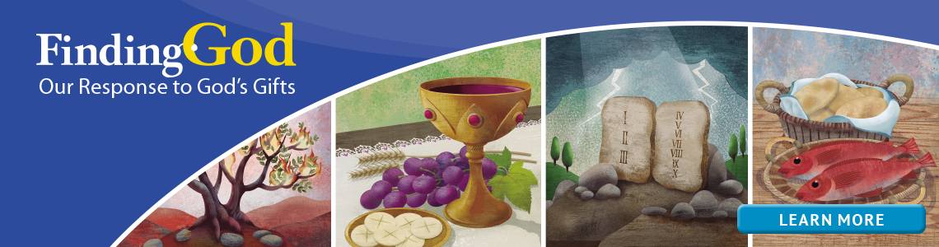
St. Luke School and SMRE (Sunday Morning Religious Education) are now using religion books published by Loyola Press. The sacraments of First Reconciliation and First Eucharist are covered in Finding God. The USCCB (United States Conference of Catholic Bishops) has listed Finding God among the catechetical books and series that are in conformity with the Catechism of the Catholic Church.

To help parents participate in their child’s religious formation, Finding God has inserted in its lessons QR codes that may be scanned to hear or watch content related to the chapter by using an internet-enabled device.

A QR code also provides access to other materials that support and encourage parents in their role as their child’s most influential catechist.

Which chapters in Finding God focus on the sacraments?

The Ten Commandments are covered in chapter 6
The Sacrament of Penance is covered in chapters 12 and 13
The formation of conscience is covered in chapter 22, 23, and 24
The Sacraments of Christian Initiation are covered in chapter 16
The Mass and the Sacrament of Communion are covered in chapters 17, 18 and 19.

What else does Loyola Press publish about the content in grade 2 Finding God?

Each unit opens with the story of a saint whose holy life and response to God's love illustrate the unit theme. Every session in the Student Book follows a consistent pattern beginning with Engage, a question and opening prayer to lead into the session. The second step is Explore where children deepen their understanding of Scripture and doctrine as they read, discuss, experience and pray. In Explore Further, children leave the book to explore and discuss works of traditional and modern art from around the world that connect to the unit themes. Then the children Reflect and

4
Respond through various forms of prayer and through review of what they have learned. Every unit closes with a section called Celebrating the Liturgical Year. Throughout the units, special features and sidebars highlight Scripture, Liturgy, Saints, Sacred Sites and interesting facts. A free copy of Catholic Prayers for Catholic Families and access to seven parent e-newsletters provide support for families.

WHAT IS THE SACRAMENT OF RECONCILIATION ALL ABOUT?

Do you have a copy of the Catechism of the Catholic Church in your home library? It is an excellent tool to deepen in our faith as Catholics. To purchase an inexpensive catechism for less that $15., go to Amazon.com or go to The Celtic Cross, a Catholic Religious Goods Store at 1512 W. 86 Street. To order the Catechism of the Catholic Church or other religious items, you may call the Celtic Cross at 317-777-0059.

Below is what the Catechism of the Catholic Church teaches on
the Sacrament of Reconciliation

The Catechism of the Catholic Church provides the groundwork for understanding what Catholics believe.

1485 "On the evening of that day, the first day of the week," Jesus showed himself to his apostles. "He breathed on them, and said to them: 'Receive the Holy Spirit. If you forgive the sins of any, they are forgiven; if you retain the sins of any, they are retained"' (Jn 20:19,22-23).
1486 The forgiveness of sins committed after Baptism is conferred by a particular sacrament called the sacrament of conversion, confession, penance, or reconciliation.
1487 The sinner wounds God's honor and love, his own human dignity as a man called to be a son of God, and the spiritual well-being of the Church, of which each Christian ought to be a living stone.
1488 To the eyes of faith no evil is graver than sin and nothing has worse consequences for sinners themselves, for the Church, and for the whole world.
1490 The movement of return to God, called conversion and repentance, entails sorrow for and abhorrence of sins committed, and the firm purpose of sinning no more in the future. Conversion touches the past and the future and is nourished by hope in God's mercy.
1491 The sacrament of Penance is a whole consisting in three actions of the penitent and the priest's absolution. the penitent's acts are repentance, confession or disclosure of sins to the priest, and the intention to make reparation and do works of reparation.
1493 One who desires to obtain reconciliation with God and with the Church, must confess to a priest all the unconfessed grave sins he remembers after having carefully examined his conscience. the confession of venial faults, without being necessary in itself, is nevertheless strongly recommended by the Church.
1494 The confessor proposes the performance of certain acts of "satisfaction" or "penance" to be performed by the penitent in order to repair the harm caused by sin and to re-establish habits befitting a disciple of Christ.

5
1495 Only priests who have received the faculty of absolving from the authority of the Church can forgive sins in the name of Christ.
1496 The spiritual effects of the sacrament of Penance are: - reconciliation with God by which the penitent recovers grace; - reconciliation with the Church; - remission of the eternal punishment incurred by mortal sins; - remission, at least in part, of temporal punishments resulting from sin; - peace and serenity of conscience, and spiritual consolation; - an increase of spiritual strength for the Christian battle.
Are all sins equal?
When a person goes to confession, all mortal (grave) sins must be confessed. Venial (lesser) sins do not need to be confessed, but it is recommended to do so. When only venial sins are confessed, the person is making a devotional confession.

To learn more about the difference between mortal and venial sins, read paragraphs 1854-1859.

Some practical spiritual benefits from going to confession
It helps us to grow in self-knowledge. St. Augustine and many other saints and doctors of the Church have taught that knowing ourselves is essential to having a healthy spiritual life. Self-knowledge helps us to appreciate our need for God’s ongoing help and grace in our lives. Frequent Confession reminds us that we need to depend on God in order to overcome temptations and sin.

It helps us to overcome bad habits and sin in our lives.
The grace we receive from the sacrament helps us to win the battle against bad habits or vices. Bad habits are acquired with the repetition of bad actions. Bad habits may be broken more quickly and effectively when we go to confession regularly.

The conscience is purified
The conscience, if well formed, teaches us what is right or wrong. Sin often distorts the conscience or makes it insensitive to the truth. Confession purifies our conscience so that we can recognize God’s will in the circumstances of our daily lives. Confession enlightens and purifies our conscience.

It helps us become more like Christ.
It imparts grace to our souls. Grace strengthens us to become more conformed to Jesus Christ in word and deed. Every canonized saint in the Church went to confession not only with the desire to overcome sin and sinful tendencies, but also to become more loving and Christ-like. Confession is the launching pad for a life of authentic holiness.

It strengthens our will.
God strengthens our will with his grace. Through confession, we gain self-control and grow in our desire and commitment to resist the temptations that cross our path in life. We become more determined to do God’s will and not our own. Self-will, self-absorption and self-seeking are the road map to sin that leads us away from the Will of God.

6
Below is what the Catechism of the Catholic Church teaches on
the Sacrament of the Eucharist

From the paragraphs below in the Catechism of the Catholic Church, we learn the following:

1324 The Eucharist is "the source and summit of the Christian life." The other sacraments, and indeed all ecclesiastical ministries and works of the apostolate, are bound up with the Eucharist and are oriented toward it. For in the blessed Eucharist is contained the whole spiritual good of the Church, namely Christ himself, our Pasch."

1337 The Lord, having loved those who were his own, loved them to the end. Knowing that the hour had come to leave this world and return to the Father, in the course of a meal he washed their feet and gave them the commandment of love.¹⁶³ In order to leave them a pledge of this love, in order never to depart from his own and to make them sharers in his Passover, he instituted the Eucharist as the memorial of his death and Resurrection, and commanded his apostles to celebrate it until his return; "thereby he constituted them priests of the New Testament."¹⁶⁴
1338 The three synoptic Gospels and St. Paul have handed on to us the account of the institution of the Eucharist; St. John, for his part, reports the words of Jesus in the synagogue of Capernaum that prepare for the institution of the Eucharist: Christ calls himself the bread of life, come down from heaven.¹⁶⁵
1339 Jesus chose the time of Passover to fulfill what he had announced at Capernaum: giving his disciples his Body and his Blood:
Then came the day of Unleavened Bread, on which the passover lamb had to be sacrificed. So Jesus sent Peter and John, saying, "Go and prepare the passover meal for us, that we may eat it. . . ." They went . . . and prepared the passover. And when the hour came, he sat at table, and the apostles with him. And he said to them, "I have earnestly desired to eat this passover with you before I suffer; for I tell you I shall not eat it again until it is fulfilled in the kingdom of God.". . . . And he took bread, and when he had given thanks he broke it and gave it to them, saying, "This is my body which is given for you. Do this in remembrance of me." And likewise the cup after supper, saying, "This cup which is poured out for you is the New Covenant in my blood."¹⁶⁶

1340 By celebrating the Last Supper with his apostles in the course of the Passover meal, Jesus gave the Jewish Passover its definitive meaning. Jesus' passing over to his father by his death and Resurrection, the new Passover, is anticipated in the Supper and celebrated in the Eucharist, which fulfills the Jewish Passover and anticipates the final Passover of the Church in the glory of the kingdom.
"Do this in memory of me"
1341 The command of Jesus to repeat his actions and words "until he comes" does not only ask us to remember Jesus and what he did. It is directed at the liturgical celebration, by the apostles and their successors, of the memorial of Christ, of his life, of his death, of his Resurrection, and of his intercession in the presence of the Father.¹⁶⁷
1342 From the beginning the Church has been faithful to the Lord's command. Of the Church of Jerusalem it is written: They devoted themselves to the apostles' teaching and fellowship, to the breaking of bread and the prayers. . . . Day by day, attending the temple together and breaking bread in their homes, they partook of food with glad and generous hearts.¹⁶⁸
7
1343 It was above all on "the first day of the week," Sunday, the day of Jesus' resurrection, that the Christians met "to break bread."¹⁶⁹ From that time on down to our own day the celebration of the Eucharist has been continued so that today we encounter it everywhere in the Church with the same fundamental structure. It remains the center of the Church's life.
1406 Jesus said: "I am the living bread that came down from heaven; if any one eats of this bread, he will live forever; . . . he who eats my flesh and drinks my blood has eternal life and . . . abides in me, and I in him" ( Jn 6:51, 54, 56).

Understanding Transubstantiation
“Transubstantiation” is a theological term that describes the complete change of the substance (what something is in its deepest being) of bread into the substance of Jesus Christ. While the substance changes, the accidents (external features) remain the same. What looks like a wafer, tastes like a wafer, and breaks apart like an ordinary wafer is actually the Body, Blood, Soul and Divinity of Jesus Christ.

Effects of the Eucharist in the life of Catholic

- An increased and deepened union with Jesus

- Forgiveness of venial (lesser) sins

- A strengthening to avoid future mortal (serious) sins

- A reinforced union with all other believers, who are the Church

- A preparation of the body for bodily resurrection

8
March 2, 2024 FIRST HOLY COMMUNION RETREAT

Children and at least one parent should attend the First Holy Communion Retreat that will be offered in the parish on Saturday, March 2, from 9:00 to 11:30 a.m.

Please arrive with your child no later than 9:45 a.m. Sign in and you and your child will be assigned a group.

The retreat ends with Benediction.

What is Benediction?

Benediction is a devotional ceremony celebrated whereby a priest or a deacon blesses the congregation with the Eucharist at the end of a period of adoration.
Benediction follows exposition of the Blessed Sacrament, i.e., the placing of the consecrated Host in a monstrance (pictured below) and set upon the altar. The blessing with the Eucharist is preceded by a period time for readings of the word of God, songs, prayers, and a period for silent prayer.
The readings, songs, and prayers are meant to direct attention to the worship of Christ truly present, in the Eucharist. Since the mystery of the Eucharist which is the source and summit of our Christian life (The Catechism of the Catholic Church 1324-1327), it is very appropriate that our retreat is concluded with Benediction.
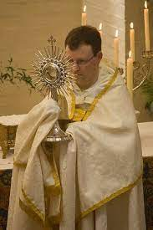

9
An Act of Spiritual Communion
My Jesus,
I believe that You are present in the Most Holy Sacrament.
I love You above all things,
and I desire to receive You into my soul.
Since I cannot at this moment receive You sacramentally,
come at least spiritually into my heart.
I embrace You as if You were already there
and unite myself wholly to You.
Never permit me to be separated from You.
Amen.

An Act of Spiritual Communion for Children

Jesus, I believe that You are really present in Holy Communion. I believe that the Eucharist contains Your Body, Blood, Soul and Divinity, but we can only see the Hosts. You are hidden in them.

Jesus, you are the Son of God. You are everywhere!
That means that I am never alone and I am always loved.
Help me to love you with all my heart.

I am happy and excited to receive You into my soul on the day of my First Communion in April.
I know that I can receive You spiritually and fill me with your love.

(Pause and invite Jesus to come into your soul)

I want to love you today, tomorrow and forever and ever. Amen.

10

First Eucharist 2024 Banner
Top of banner

The banner is to hang vertically
and not
horizontally

You will receive the following: 16 X 20 white felt banner
Supplies You Will Need To Have On Hand:
- Creative ideas!!!
- Scissors, fabric glue, felt or other fabric, or ribbon, etc.
- No glitter, fake fruit, wheat or heavy items.
- No wooden sticks should be used as supports.

Instructions:
Help your child to design a banner that he or she will be proud to have
displayed before the Catholic community of St. Luke. Also, it should
be one that represents the child’s personal faith experience as he or she
prepares for First Eucharist. You will probably want to incorporate
Eucharistic symbols.
Feel free to be creative and use other materials. Do not substitute banner material or create a bigger banner. You may need to iron the felt (low heat) before working with it. Attaching felt shapes, trims, and letters can be done in a number of ways.
To attach large shapes, it would be helpful to use Ultra-hold Heat-n-Bond. The fusible material is available at Walmart (in sewing section), Jo Ann Fabrics, or Cloth World. It is very useful to trace patterns, etc., because the Heat-n-Bond is applied to a piece of felt and then a pattern can be traced onto the paper backing. This allows for easier cutting and cleaner lines on the shapes.
Glue can be used but Fabric Glue, tacky glue, or hot glue guns should be used. Elmer’s glue will not adhere to the felt. Pattern books and books on banner making may be helpful; the local library should have some on hand.
Since the banners will be on the stone walls of the church attached by two-sided tape. DO NOT GLUE OR ATTACH HEAVY ITEMS TO THE BANNER. DO NOT ATTACH A STICK TO THE TOP OF THE BANNER.

Rationale: Our hope is that this activity will provide your child with an opportunity to express the Faith that is developing through signs or symbols that are particularly meaningful to him or her.

Purpose: The banner will be used to decorate the church the weekend of First Eucharist. It is our hope that your child will feel more a part of the celebration if his or her creative expression is a part of the décor.
Due Date: Please bring the banner to your child’s First Eucharist practice on Thursday, April 25. If we do have practice, it will be on Thursday, April 25 at 6:15 p.m. (for the 10:00 a.m. Mass) or 7:15 p.m. (for the 1:00 p.m. Mass). Mass selections will be made no earlier than at the January 11, 2024 parent meeting.

First Communions will be celebrated on Saturday, April 27 at 10:00 a.m. or 1:00 p.m. In January-February you will receive information on the Mass Preferences, seating arrangements, and photography.
Please pin a card with your child’s name on the back of the banner, or include your child’s name on the banner as part of the design.

11

Questions about the First Communion Masses
on April 27

What is the seating arrangement for the First Communion Mass?

The First Communicants initially sit together as a group at the beginning of Mass. At the Sign of Peace, the children will return to their parents’ pew. Assigned seating will be given to the parents and the First Communicant. Each pew will have several First Communicants with their parents. Other siblings, unless infants or toddlers, will be seated in the unreserved pews with other relatives or friends.

Is there a dress code for First Communion?

Yes. See below for the general instructions.

Girls
- White dress
- White veils or floral wreathes
- No purses or gloves during Mass

Boys

- Suits or sports coats are appropriate
- Dress shirt and tie, or dress shirt and vest
- No prayer books, rosaries or objects should be held in the hands during the Mass

*The Celtic Cross Catholic Gift Shop, 1512 W. 86th Street, 46260, provides dresses, veils, ties and many religious items. They do not carry suits for boys. Their telephone number is 317-777-0059.

12
When are the banners due?
The banners need to be returned on the evening of practice. Parents will be asked to choose the 10:00 a.m. or the 1 p.m. Mass for their child. Forms will be filled out by parents, including the Mass Preference Form, and submitted at the parent meeting at 6:30 p.m., Thursday, January 11.

Ongoing faith formation for parents.
Why you should register for FORMED.ORG.?

As your children learn more about their Catholic faith, we invite parents to also become better informed about Catholicism through our free parish subscription to FORMED.

FORMED has inspiring movies and video-based studies, audio talks and e-books from the Church's most compelling speakers and authors. Call it a “Faith CE – a Faith Continuing Education” resource.

- Fan the flames of your faith by preparing for Mass each Sunday by watching an insightful five-minute video on the Sunday Readings using Opening the Word
- Enjoy a family movie night by watching an entertaining and meaningful religious video
- Enrich your marriage with the award-winning video program BELOVED
- Help your children grow in faith and character with engaging children’s materials.

Sign up is EASY! Simply go to https://www.stluke.org/care/grow/formed There is no charge to register for Formed.Org .

Want to get FORMED on-the-go? Learn more at app.formed.org to download the FORMED app for all your smart devices. Then, beautiful Catholic content is only 1 click away, anytime and anyplace

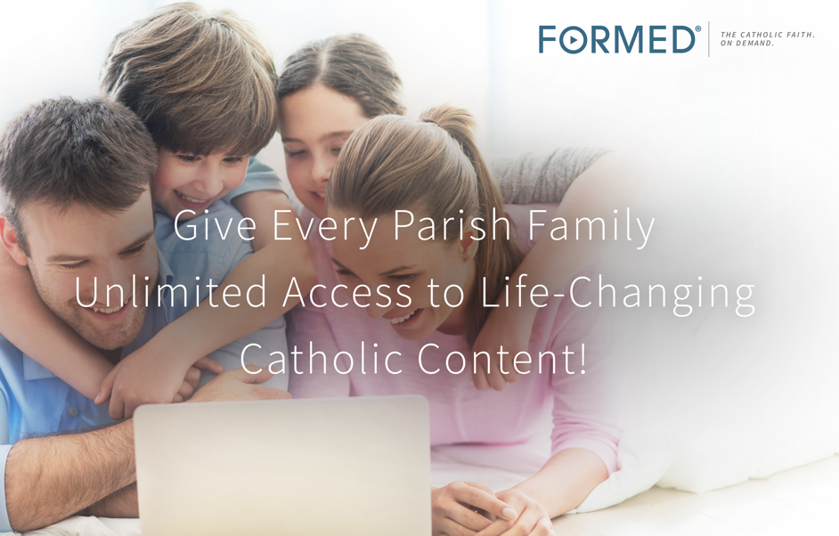

300+ episodes of video-based study programs
35+ feature films and movies
45+ audio presentations
25+ eBooks
Available in English and Spanish!
Available 24/7
13
Miscellaneous Questions and Comments Regarding Sacramental Preparation

1. What role do parents play in the sacramental preparation of their children?
Parents are the most important adult Catholics in the life of their child. At baptism you promised God that you would raise your son or daughter in the Catholic faith. Concretely, this means that you will provide the necessary religious education for your child in the faith. It also means that you will show your child that faith in God is something real and practical and part of everyday life. The expectation is that you will bring your son or daughter to Mass every Sunday and holy day of obligation.

2. How often should Catholics receive Holy Communion? The Church encourages the faithful to receive Holy Communion at Mass. In other words, the Church encourages the faithful to receive the Eucharist faithfully and frequently. However, receiving the Eucharist is only “required” at least once a year. If a person has committed mortal sin, he or she must go to sacramental confession before receiving Jesus in the Eucharist.
Do adults and children need to fast before receiving Holy Communion?
The Church proscribes a one-hour fast before receiving the Eucharist. This means we don’t eat or drink. No coffee, tea or other beverages should be consumed. Unless there is a medical reason to do otherwise, the fast is obligatory. Note that it is also inappropriate to chew gum or eat candy in church.

Food and drink should never be casually consumed in church at any time! To do so would be to show disrespect to Jesus in the Tabernacle. An example of an exception would be if a person has a medical condition like diabetes that requires the person to consume a sugared drink or pieces of candy.

3. What prayers should I teach my child? Monsignor Schaedel directs all teachers and catechists to distribute Catholic prayer books at the beginning of the year that he has approved. It is highly recommended that parents help their children memorize the basic prayers for their age group. Children receiving first reconciliation should memorize the Act of Contrition. The prayer appears at the bottom of page 15.

Are you aware that at St. Luke, we have a perpetual adoration chapel? As you enter the front doors of the church, turn right. The first door on the right, before the Daily Mass Chapel, is the perpetual adoration chapel. The Blessed Sacrament is exposed 24/7 for adoration. We encourage parents to bring their children for brief visits to adore our Lord when possible. Currently, the Blessed Sacrament is exposed in the Daily Mass Chapel between weekday Masses only.

4. What information do I need to submit before my child receives the sacraments?
We are required by the Church to obtain the Baptismal information before a child is allowed to receive the sacraments of Penance and Communion. Please obtain a copy of your child’s baptism certificate from the church in which he or she was baptized. If your child was baptized at St. Luke Parish, you need only provide us with the date of Baptism.

14
5. Is there a fee for classes?
The tuition fee for the program to prepare children for the sacraments in the SMRE program is $85. This fee covers the cost of the student textbook, workbook and other materials needed in the program. Please check the religious education website for online donations.

St. Luke School covers the cost of materials used for sacramental preparation. No additional
fees are required for school parents. However, the registration form needs to be submitted with the baptismal information!

6. Why do young children need to be prepared for First Penance before First Eucharist?
It is the practice or the norm throughout the Church that children, before they receive their First Eucharist, first receive the Sacrament of Penance or Reconciliation.

The Church teaches that “children must go to the sacrament of Penance before receiving Holy Communion for the first time” (Catechism of the Catholic Church, No. 1457); and, “It is primarily the duty of parents, as well as the duty of pastors, to take care that the children who have reached the use of reason are prepared properly and, after they have a sacramental confession, are refreshed with this divine food” (Canon 914).

7. What is the age of reason and how is this related to the sacraments?
Children are prepared for Penance and Communion when they have reached the age of
reason. Infants and small children lack sufficient maturity to distinguish between right and wrong and therefore are not considered responsible for their actions. “With the completion of the seventh year, a minor is presumed to have the use of reason” (Canon 97.2). Of course, this age is not exact. Some may arrive at this age earlier, others later or not at all, depending on intelligence and other critical factors.

Children who have reached the age of reason are able to think abstractly and apply general principles to specific life situations. Children who have reached the age of reason know the difference between good and evil.

ACT OF CONTRITION
(TO BE MEMORIZED BEFORE FIRST RECONCILIATION)

My God, I am sorry for my sins with all my heart. In choosing to do wrong and failing to do good, I have sinned against you whom I should love above all things. I firmly intend, with your help, to do penance, to sin no more, and to avoid whatever leads me to sin. Our Savior Jesus Christ suffered and died for us. In his name, my God, have mercy.

